**Laboratory work 4**

1.  
a) What are the main phases in the database design? What is done on each development phase?

* Initial phase - characterize fully the data needs of the prospective database users.
* Second phase - when every data requirement is stored and analyzed, the next thing that we need to do is creating a conceptual database plan and choosing a data model.
* Final Phase - implementation of the database from an abstract data model.

b) What is the entity-relationship **(ER) data model**?

* Models an enterprise as a collection of entities and relationships
* Entity: a “thing” or “object” in the enterprise that is distinguishable from other objects
* Described by a set of attributes
* Relationship: an association among several entities.

2.   
a) Create entity **“Student”** with at least **5 attributes** (One for each type of attribute: **simple, composite, derived, multivalued**)

|  |
| --- |
| Student |
| *student__id*  *name*  *first_name*  *last_name*  *address*  *street*  *home_number*  *city*  *region*  *date_of_birth*  *age()*  *{phone_number}* |

b) Create entities **“University”, “Course”, “Dormitory”, “Teacher”, “Office of the Registrar”** with at least 3 attributes each. (Entity types should be correct on data model)

|  |
| --- |
| University |
| *name*  *students*  *faculties* |

|  |
| --- |
| Course |
| *title*  *instructors*  *credits* |

|  |
| --- |
| Dormitory |
| *university*  *address*  *capacity* |

|  |
| --- |
| Teacher |
| *Teacher_id*  *name*  *first_name*  *last_name*  *discipline* |

|  |
| --- |
| Office of the Registrar |
| *name*  *first_name*  *last_name*  *{phone_number*  *{email_address}* |

1. Give examples for **one-to-many, one-to-one, many-to-many, many-to-one** relations. (Draw the examples as a scheme)

**one-to-many**

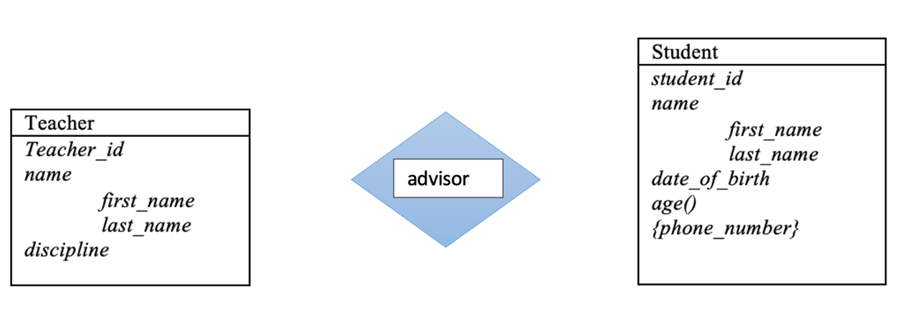

**one-to-one**



**many-to-many**



**many-to-one**



1. Create ER data model with relations using data from the second task.

belongs

works

studies

learns

teaches

1. Create ER data model for IT company. (**At least 5 entities and 8 relations**)

|  |
| --- |
| Departments |
| *dept_name*  *city* |

|  |
| --- |
| Employee |
| *investor_id*  *name*  *first_name last_name* |

works

belongs

|  |
| --- |
| Company |
| *company_id*  *company_name* |

belongs

invents

|  |
| --- |
| Investor |
| *investor_id*  *name*  *first_name*  *last_name*  *main_place_of_work* |

|  |
| --- |
| Start-ups |
| *startup_id*  *name*  *info*  *startup_cost* |

|  |
| --- |
| Investments |
| *type*  *investment_amount* |

|  |
| --- |
| Clients |
| *client_id*  *name*  *first_name last_name* |

|  |
| --- |
| Stuffs |
| *stuff_id*  *name*  *stuff_cost*  *function* |

buys

creates

invests

pays